- 5G Throughput vs SNR with Modulation Labels

Aim:
To plot throughput vs SNR for QPSK, 16-QAM, 64-QAM, and 256-QAM in a simple 5G-like AWGN system and label each modulation curve.

Software Required
- MATLAB / Octave

Theory (Simple)
- Higher SNR allows higher-order modulation (QPSK → 16QAM → 64QAM → 256QAM).
- Spectral efficiency = log₂(M) bits/symbol.
- Simple throughput model:
Throughput = BW × log₂(M) × (1 – BER)
- BER decreases as SNR increases, so throughput increases.

Procedure (Simple)
- Choose modulations: 4, 16, 64, 256 (M-QAM).
- Sweep SNR from –5 to 30 dB.
- Compute BER using simple Q-function formula.
- Compute throughput.
- Plot throughput vs SNR and label curves.
Pseudocode:
set BW = 20e6; % Hz
set R_c = 0.5; % code rate
mods = [4, 16, 64, 256]
SNR_dBs = -2:0.5:30

for each M in mods:
for each snr_db in SNR_dBs:
snr_lin = 10^(snr_db/10)
ber = BER_M_QAM_approx(M, snr_lin)
throughput = BW * R_c * log2(M) * (1 - ber)
store throughput
plot throughput curves vs SNR_dBs (convert to Mbps)
find SNR thresholds where one curve becomes higher than previous
annotate plot with modulation labels

Simple MATLAB Code
clear; clc; close all;

%% PARAMETERS
BW = 100e6; % Bandwidth in Hz (100 MHz)
SNR_dB = 0:5:30; % SNR range in dB
mod_schemes = {'QPSK','16QAM','64QAM'}; % Modulation schemes
bits_per_symbol = [2 4 6]; % Bits per symbol

throughput = zeros(length(mod_schemes), length(SNR_dB));

%% CALCULATE THROUGHPUT
for m = 1:length(mod_schemes)
k = bits_per_symbol(m); % bits per symbol
for s = 1:length(SNR_dB)
snr_linear = 10^(SNR_dB(s)/10); % Convert dB to linear
C = BW * log2(1 + snr_linear); % Shannon capacity in bits/sec
throughput(m,s) = C * (k/6); % Adjust relative to 64QAM efficiency
end
end

%% PLOT THROUGHPUT
figure;
colors = {'b','r','g'}; hold on;
for m = 1:length(mod_schemes)
plot(SNR_dB, throughput(m,:)/1e6, 'LineWidth',2, 'Color', colors{m});
% Add text label at the end of the curve
text(SNR_dB(end)+0.5, throughput(m,end)/1e6, mod_schemes{m}, 'Color', colors{m}, ...
'FontWeight','bold','FontSize',10);
end

grid on;
xlabel('SNR (dB)');
ylabel('Throughput (Mbps)');
title('5G Throughput vs SNR for Different Modulation Schemes');
xlim([min(SNR_dB) max(SNR_dB)+5]); % leave space for labels

OUTPUT:

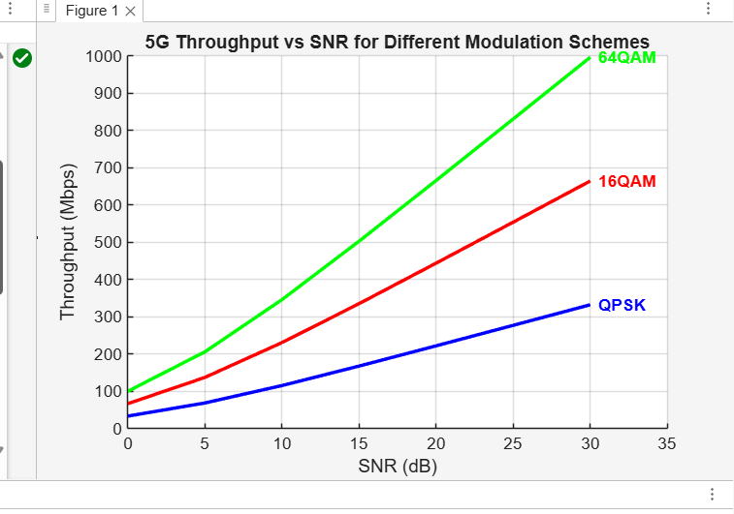

Result: Throughput increases with SNR, and higher-order modulations (16QAM, 64QAM, 256QAM) give higher throughput only at higher SNR levels.

